Practical No: 08

**Aim:** IoT based web based home automation using raspberry pi.

**Hardware Required:**

1. Raspberry Pi 3B+
2. Ethernet Cable
3. Monitor
4. HDMI to VGA convertor
5. Micro SD card (any class best is class 10)
6. Adaptor with 5v 2A
7. USB mouse
8. USB keyboard
9. Relay board
10. Female – Female jumper wires.

**Software Required:**

1. Raspbian OS
2. Node-RED
3. NPM

**Procedure:**

1. **Hardware Setup:**

* Connect according to the figure.

GPIO20 🡪 IN1

GPIO21 🡪 IN2

PIN2 🡪 VCC (5v)

PIN6 🡪 GND

*Black wire is the GND (ground)

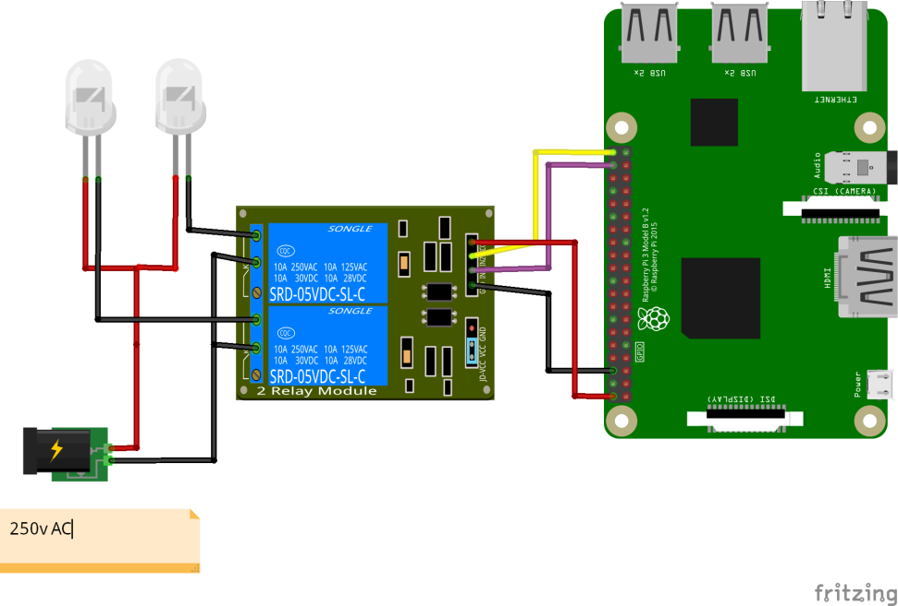

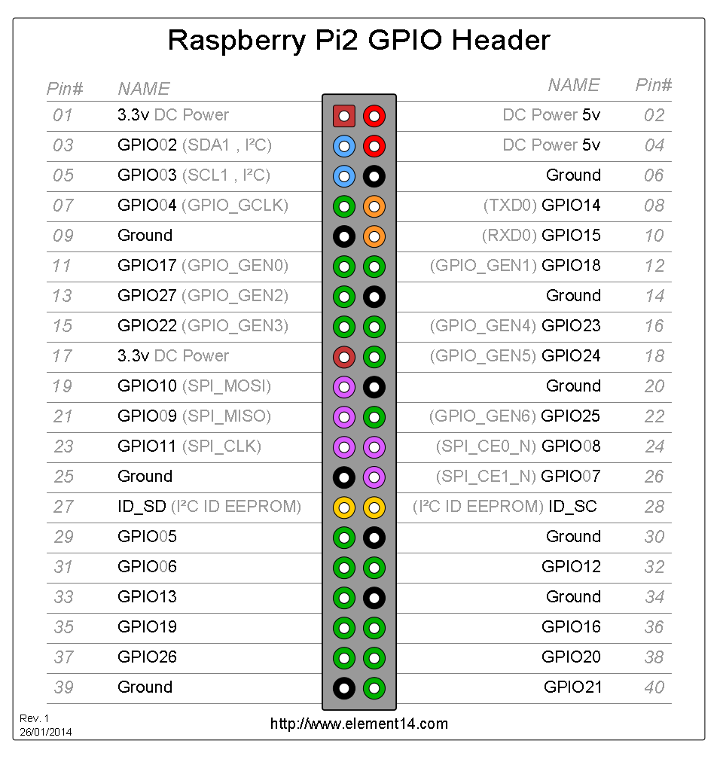

1. **Software Setup:**

* Open Terminal and type in the following commands
  + sudo apt install npm
  + update-nodejs-and-nodered
  + npm install node-red-dashboard
  + node-red-start
* Open browser and type the URL <http://localhost:1880/>

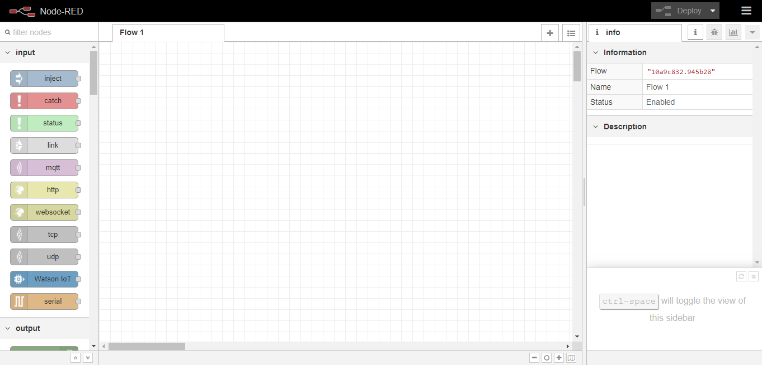

* Drag and drop 2 “switch” components from the left panel under dashboard category. 
* Drag and drop 2 “rpi gpio” components from the left panel under Raspberry Pi

category.



* Connect as shown in the figure.

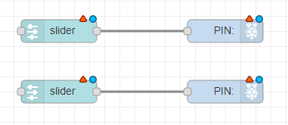

* Double click on any one component and create new Group by clicking the pencil icon.
* Click on the pencil icon next to Tab to add new Tab
* Click on “Add”
* Click on “Update”
* Click on “Done”
* Add the second switch to the same group which we have just created. ([Home] Default)
* Double Click on rpi gpio component and select GPIO20.
* Do the same with the other rpi gpio component but this time select GPIO21.
* Once you do the above steps correctly you will see no read triangle on the top.
* Click on “Deploy” on top.

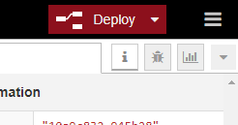

* Open <http://localhost:1880/ui> in new tab.

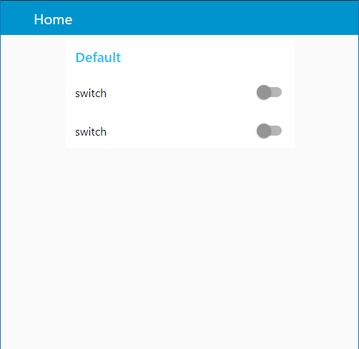

**Precautions:**

* If it is a fresh flash of “*Raspbian OS sudo”* apt update and “*sudo apt upgrade”*  is a must thing.
* Connect the components before powering on the device and double check your connections.
* Take the help of the professor in connection as this project includes use of high voltage.

**Conclusion:**

* We are able to control two AC powered light bulbs using the web interface.